**Coding Task 6 (Matplotlib)**

**Date: 20/09/20**

**Deadline: 22/09/20**

**Submission Link: https://forms.gle/FM6FzkG6nHjmpZa38**

1)Write a program to plot the following. Take random x and y values.

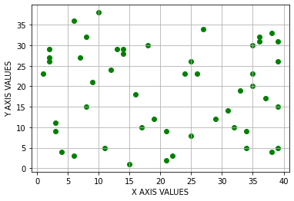

2)Write a program to generate the following plot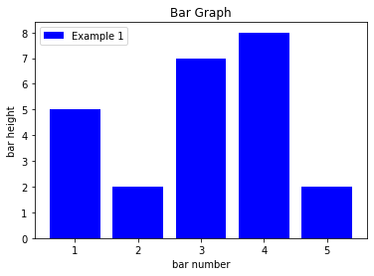

3)Write a program to generate the following line plot

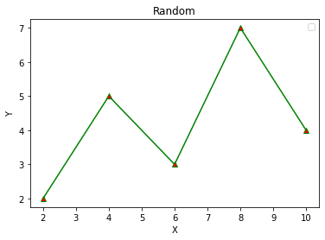

4) Write a program to generate the parabola. (y=x^2)

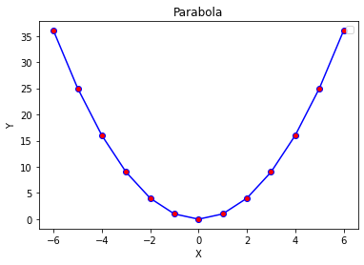

5) Write a program to plot a pie chart. It’s up to you choose any colour, any data. Make it as attractive as you could.